|  |  |  |  |  |  |  |  |  |
| --- | --- | --- | --- | --- | --- | --- | --- | --- |
| **TABLE 5 Group Descriptive Statistics and Tests of Equality for the Estimation Sample in the Two-Group** | | | | | | | | |
| **Independent Variables** | Dependent Variable Group Means:  area | | | Test of Equality of Group Means* | | | Minimum *Mahalanobis* D2 | |
|
| **Group1width=1**  **n=306** | **Group2 width=2**  **n=664** | **Group3**  **width=3**  **n=520** | **Wilks’ Lambda** | **F value** | **Significance** | **Minimum**  **D2** | **Between Groups** |
|
|
| 經度 | 121.039 | 120.798 | 120.779 | .955 | 28.284 | .000 | .001 | 1 and 2 |
| 緯度 | 23.842 | 23.918 | 24.115 | .982 | 11.019 | .000 | .106 | 2 and 3 |
| 里程km | 11.672 | 6.537 | 5.012 | .861 | 95.780 | .000 | .227 | 2 and 3 |
| 路肩寬度 | 0.836 | 1.565 | 1.972 | .868 | 90.445 | .000 | .200 | 2 and 3 |
| 小型車數 | 2730.235 | 7412.722 | 11119.914 | .847 | 107.443 | .000 | .093 | 2 and 3 |
| 大客車數 | 36.992 | 84.844 | 162.654 | .907 | 60.759 | .000 | .263 | 2 and 3 |
| 大貨車數 | 98.437 | 394.670 | 577.246 | .889 | 74.299 | .000 | .045 | 2 and 3 |
| 全聯結車數 | 1.806 | 10.646 | 12.117 | .962 | 23.268 | .000 | .058 | 2 and 3 |
| 半聯結車數 | 69.895 | 338.316 | 337.282 | .958 | 26.229 | .000 | .083 | 2 and 3 |
| 機車數 | 1202.146 | 2735.721 | 5554.668 | .888 | 75.056 | .000 | .239 | 2 and 3 |
| 總流量PCU | 4147.709 | 11008.276 | 17080.807 | .803 | 146.030 | .000 | .268 | 2 and 3 |
| 總計車公里 | 32995.53 | 58728.46 | 79847.29 | .920 | 51.724 | .000 | .122 | 2 and 3 |
| 尖峰小時交通量PCU | 477.000 | 1139.441 | 1777.119 | .781 | 166.434 | .000 | .314 | 2 and 3 |
| 快車道數量 | 1.081 | 1.949 | 2.358 | .401 | 888.915 | .000 | .500 | 2 and 3 |
| 機慢車道數量 | 0.275 | 0.222 | 0.683 | .828 | 123.598 | .000 | .036 | 1 and 2 |

Group 1=路面寬度窄,2=路面寬度中,3=路面寬度寬

X1 地形

X2 經度

X3 緯度

X4 里程km

X5 路面寬度m

X6 路肩寬度

X7 小型車數

X8 大客車數

X9 大貨車數

X10 全聯結車數

X11 半聯結車數

X12 機車數

X13 總流量PCU

X14 總計車公里

X15 尖峰小時交通量PCU

X16 快車道數量

X17 機慢車道數量

L1: X6 ~ .

L2: X6 ~ X16

L3: X6 ~ X16 + X15

L4: X6 ~ X16 + X15 + X13

L5: X6 ~X16 + X15 + X13 + X17

Table LDA model

|  |  |  |  |
| --- | --- | --- | --- |
| model | LD1 | LD2 | accuracy |
| L1: X6 ~ . |  |  | 0.876 |
| L2: X6 ~ X16 |  |  | 0.738 |
| L3: X6 ~ X16 + X15 |  |  | 0.725 |
| L4: X6 ~ X16 + X15 + X13 |  |  | 0.742 |
| L5: X6 ~X16 + X15 + X13 + X17 |  |  | 0.812 |

Table Confusion Matrix of LDA (Trian)

|  |  |  |  |
| --- | --- | --- | --- |
|  | 1 | 2 | 3 |
| 1 |  |  |  |
| 2 |  |  |  |
| 3 |  |  |  |

Table Confusion Matrix of LDA (Test)

|  |  |  |  |
| --- | --- | --- | --- |
|  | 1 | 2 | 3 |
| 1 |  |  |  |
| 2 |  |  |  |
| 3 |  |  |  |

|  |  |  |  |  |
| --- | --- | --- | --- | --- |
|  | L1 | | L5 | |
| Independent Variables | Function1 | Function2 | Function1 | *Function2* |
| X16 快車道數量 | 1.490 | -0.372 | -1.510 | *0.561* |
| X15 尖峰小時交通量PCU | 0.142 | 0.472 | -0.180 | *-0.301* |
| X13 總流量PCU | -0.888 | 1.402 | 0.076 | *-0.016* |
| X17 機慢車道數量  X2 經度  X3 緯度  X4 里程km | 0.588 | 0.907 | -0.481 | *-0.940* |

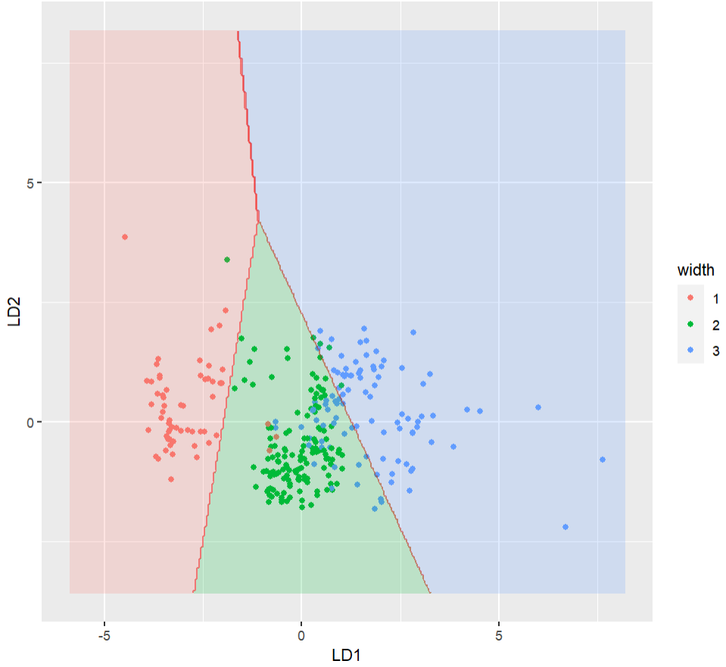

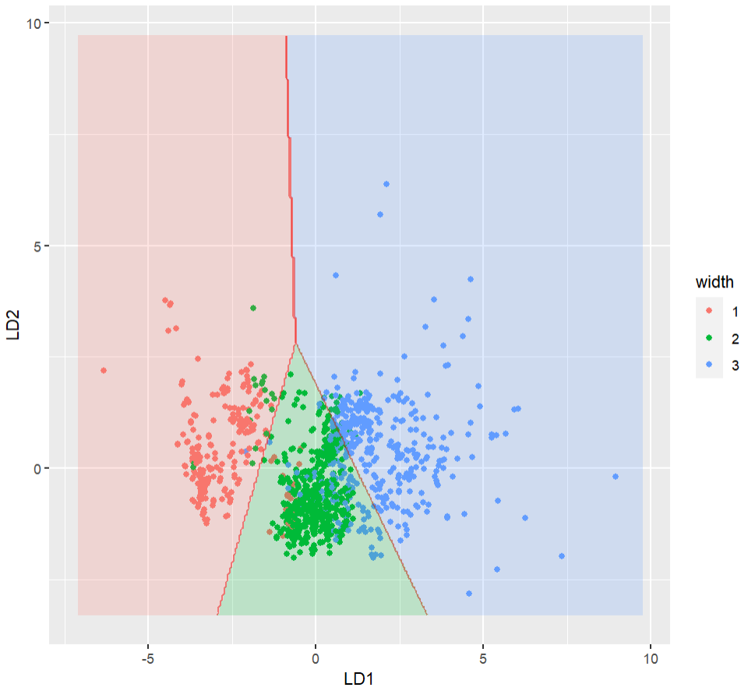 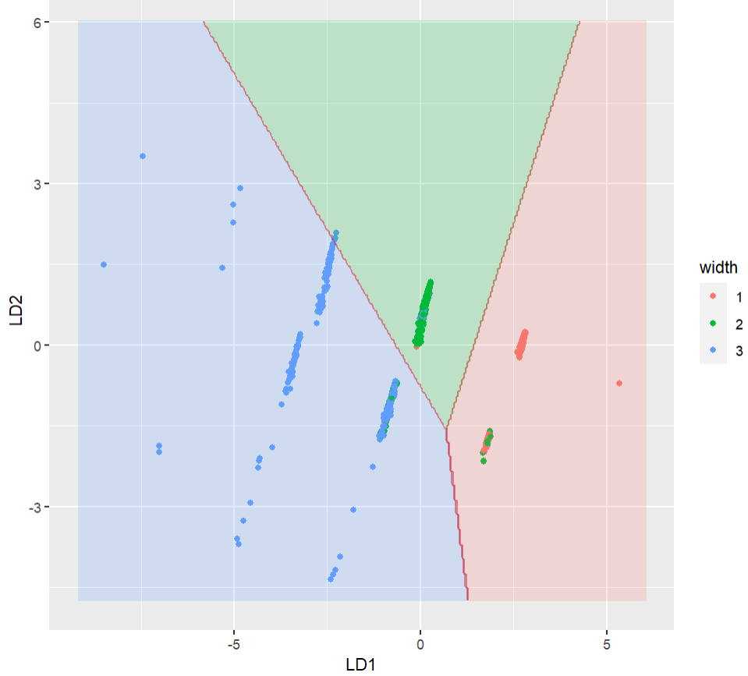 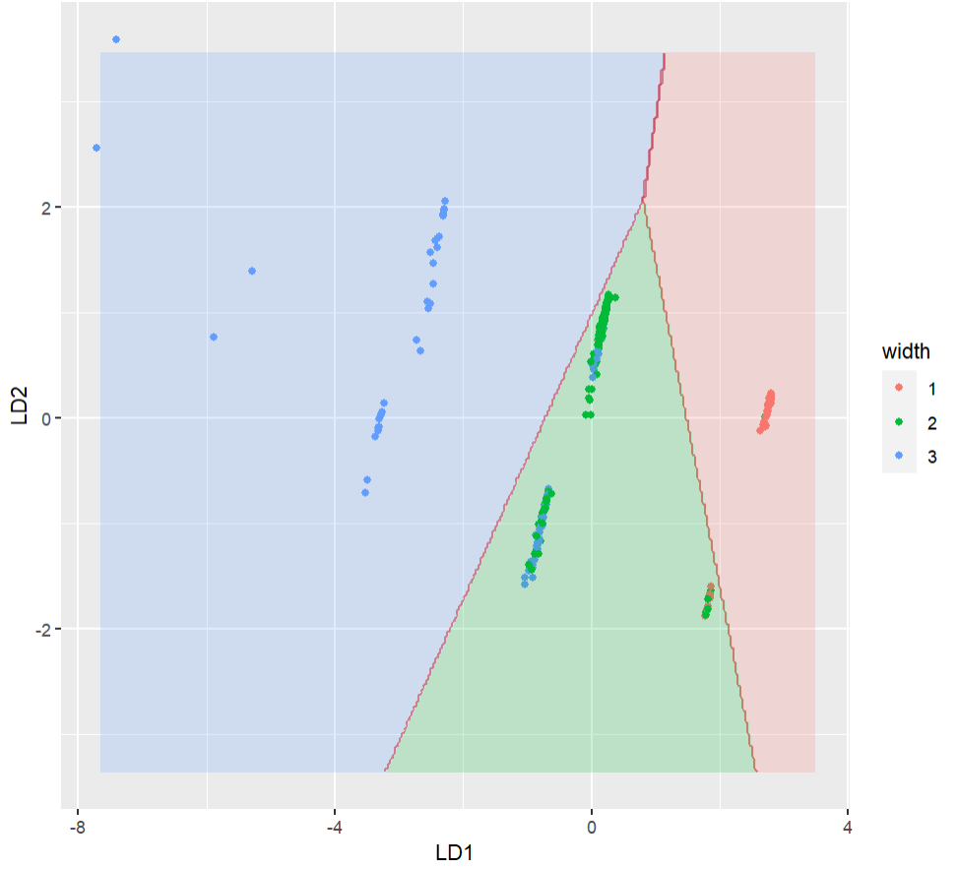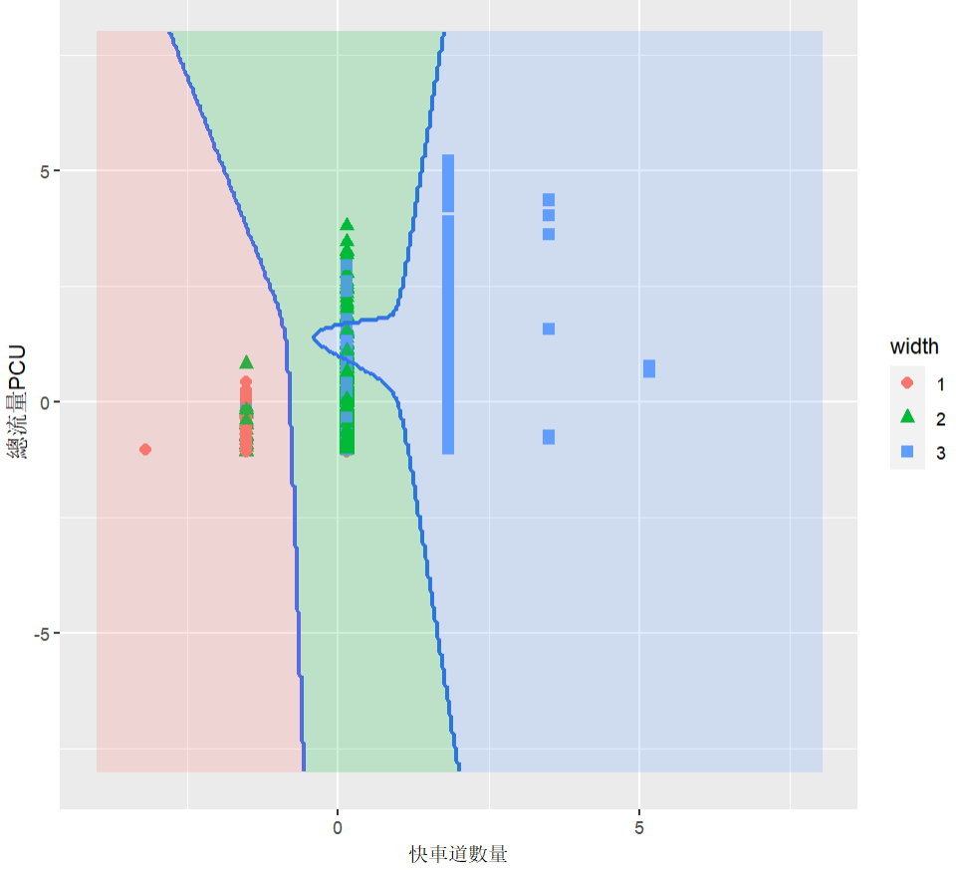

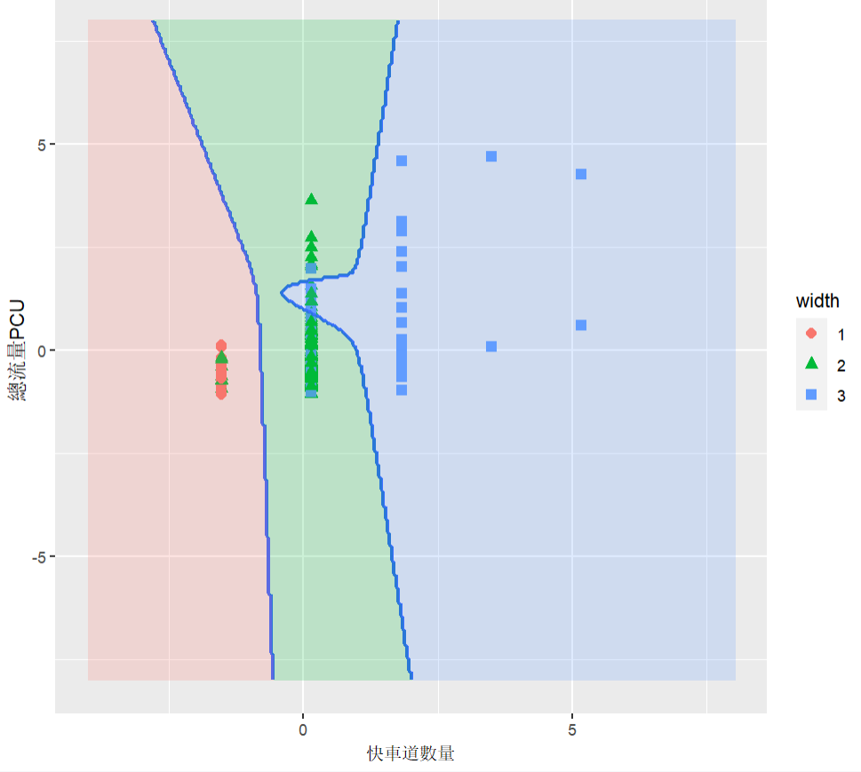

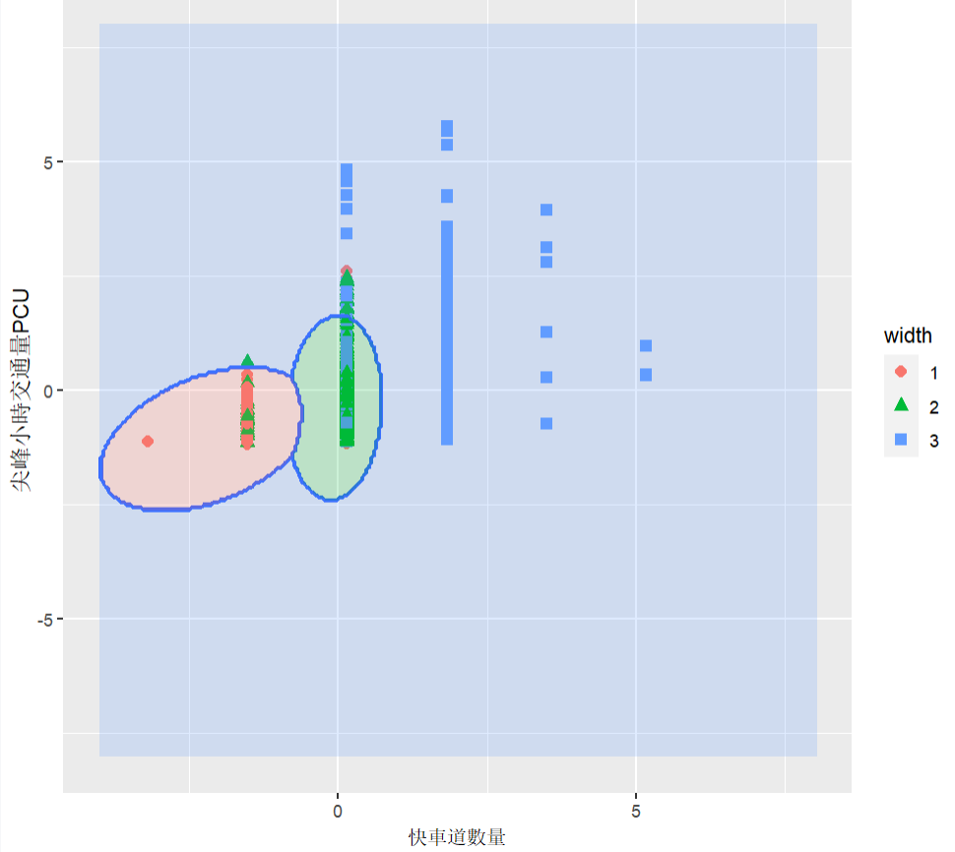

|  |  |  |  |  |
| --- | --- | --- | --- | --- |
|  | *L1* | | *L5* | |
| *Independent Variables* | *Function1* | *Function2* | *Function1* | *Function2* |
| *X16 快車道數量* | *1.490* | *-0.372* | *-1.510* | *0.561* |
| *X15 尖峰小時交通量PCU* | *0.142* | *0.472* | *-0.180* | *-0.301* |
| *X13 總流量PCU* | *-0.888* | *1.402* | *0.076* | *-0.016* |
| *X17 機慢車道數量*  *X2 經度*  *X3 緯度*  *X4 里程km* | *0.588* | *0.907* | *-0.481* | *-0.940* |